02.01 The Python Shell

Running Console or Command Line programs : Python shell

Many current computer/device interfaces use Graphical User Interfaces (GUIs) to interact with programs or applications (apps on phones).
Predating GUIs, programs worked with just text (characters – no images, pictures) typed onto a command line, using Command-Line interfaces (CLI).
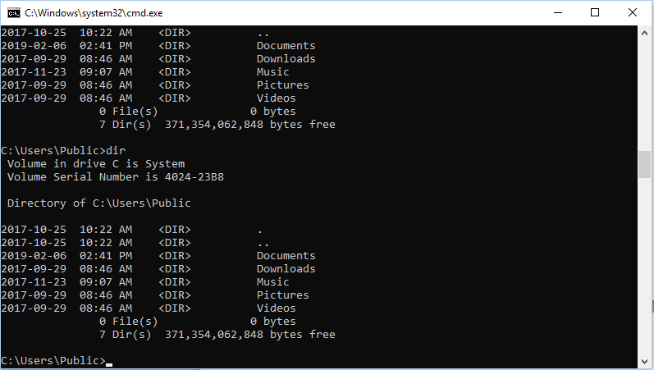

The command line consists of a text prompt and the cursor – usually a blinking square. In a CLI, the user starts a program by typing in the name of the program (with GUIs, you often start programs by clicking on an image). Input used by the programs is provided as typed characters, and output is similarly displayed as text. The Python shell is an example of a console program.

Try:
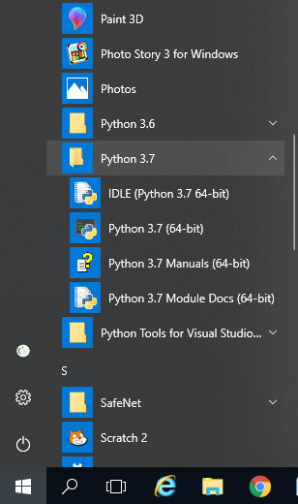
At the Windows OS, click on the Programs list, on the lower left part of the taskbar. Search for the Python 3.10 folder.
(Screen capture shows older Python versions – ignore older Python versions)

Click on the second option Python 3.10 (64-bit).

This will start the Python shell, or interpreter.

The Python shell displays as a command console window (from now on “Python shell” will be shortened to just “Python”).
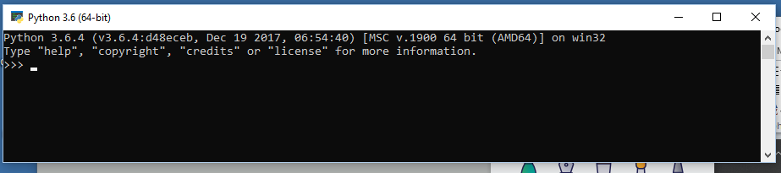

Yo

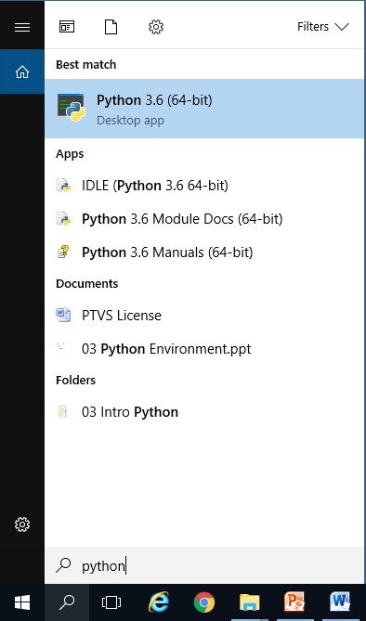
You can also use Windows’ Search feature to find and start Python :

Producing Output: Your first (second) program

It is important to know the syntax of the language. That is, the rules for writing programs. Each programming language has its own syntax. We will learn the rules of Python as we go along.

Python is sensitive to proper indenting and capitalizing. So print and Print mean different things.

Start Python. Notice the prompts are three arrows “>>>”. The flashing cursor shows where the text will appear when you type.

At the prompt type, type the following (note the use of double quotes)

print(“Hello World”)

Press enter.

The output appears on another line.

What just happened:
When Enter is pressed, the shell will :
- check the line for syntax errors, then
- convert (or compile) the source line to machine code, then
- execute or run the machine code (or binary), then
- display any results.

If Python encounters any syntax errors, Python will stop, and display syntax error messages. These messages mean the program has broken a syntax rule, and cannot continue.

Try typing:
print(“I am hungry)

Syntax error messages will indicate where the error occurred, try to categorize the type of error, give some idea on how to fix the problem. Fixing problems is called debugging. Be warned though, that often the error message may not be pointing to the right spot to fix. Good debugging comes with practice.
If Python encounters any errors while executing the code, Python will stop and display error messages. These types of errors are called runtime or logic errors. More on this type of error later.
Note that going forward, the phrases “at the prompt type:” and “Press enter” will not be written – these instructions will be understood to be done when necessary.

print()

To produce output, use the print() command or function. Python commands are written using a name or identifier, followed by parentheses. These parentheses can be empty, or have things in them, called parameters. Parameters are data or instructions (more on this later) that are provided to the commands, which the command will use.

Example:
print(“Hello world”)

print is the command. “Hello world” is counted as one parameter, and is typed as a string. “string” is a data type - more on data types later.

The print () command can print more than one string at a time; each string must be separated by a comma.

Example:
print (“I enjoy eating”, “ hot dogs”, “and pie”)

Is the next command the same?
print(“I enjoy eating”, “hot dogs”, “ and pie”)

Can you explain the difference between the two outputs?

By default, print () will print all strings separated by a blank space. The second example has two leading blanks in the last string, but the print() command does not recognize them as blanks.

Printing multiple lines, newline character

There is no automatic wrap-around, for long sentences. Unlike working in Word, programs have a lot of control on how things are printed out.
There are non-visible control characters used in programs that tell Python how to print. \n (that is, a back slash and small letter end) tells Python to start a new line when printing.

eg print (“Hey”, “look at me”) will produce Hey look at me

print (“Hey\n”, “look at me”) will produce Hey
look at me

print(“My favourite Avengers are:\n Captain America\n and Iron Man”)

\n is an example of a control (or non-printable) character – the backslash indicates the two characters combine to make a control character.

When printing long strings, the print(), split the string into smaller strings, and use the “+” concatenation operator to tell Python to join the string when printing.

eg print (“Hello, I would like fries and “ +
“pineapples and bubble tea. Can I have “ +
“a discount?”)
Exercises 02.01 Start Programming in Python

02.01.01 Starting and stopping Python

From the desktop, find the Python shell and start it up. Close it by entering in the command line
exit()

02.01.02 Practice printing.
Print out the following string
“The quick brown fox jumps over the lazy dog.”
- Using 1 print() command, on 1 line
- Using 2 print() commands, you decide where to break the line
- Using 1 print() command into three 3-word lines
Output should look like:
>>>The quick brown
>>>fox jumps over
>>>the lazy dog

02.01.03 Errors
What happens when the following code is entered (look at the statements carefully)?
- print (“The best movie is Spiderman)
- PRINT (“My name is Happy”)

Determine what caused the error (debug) so the lines print properly. Rerun the corrected code.

02.01.04 Making output nice looking
Find a paragraph of at least 100 words of a favourite topic. Using 1 print () statement for each question below:
- in the output no line is longer than 80 characters.
- in the output each sentence starts on a new line
Note: For now, don’t worry that the print statements may seem kind of long

